Test Case: tc003_SPX_Dev5_Crear_Requisicion_Spot_Tipo_Cobro_CC_Urgent
Step 1 - Enter username and password and click to button Enter : Credentials Entered
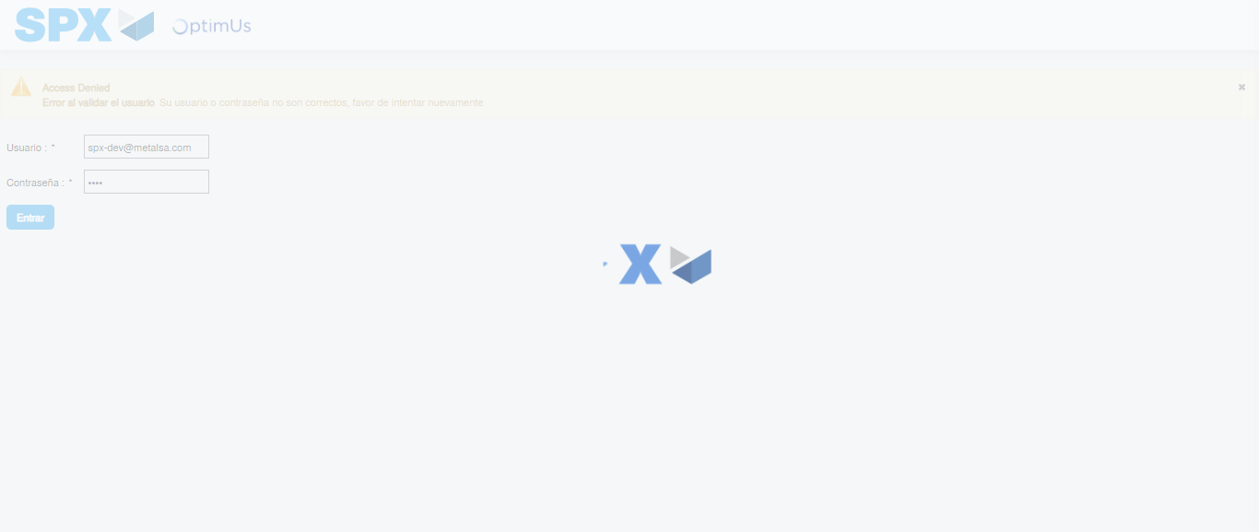Image file-name: QC_Testing-tc003_SPX_Dev5_Crear_Requisicion_Spot_Tipo_Cobro_CC_Urgent-1785344701705

Step 2 - Select to UEN and Access to Spot Buy Requisitions : UEN Correctly selected and Correct access
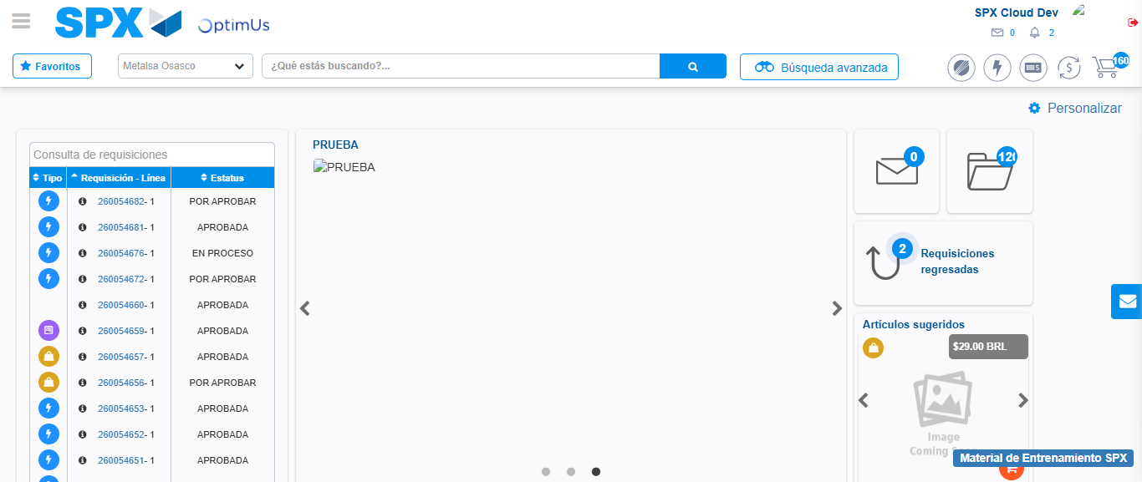Image file-name: QC_Testing-tc003_SPX_Dev5_Crear_Requisicion_Spot_Tipo_Cobro_CC_Urgent-1785344727955

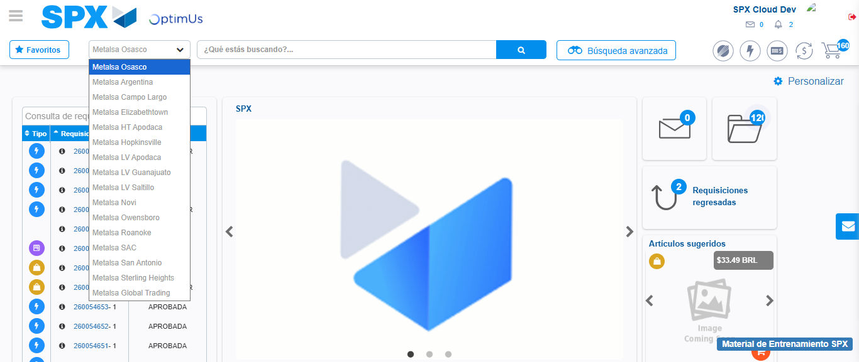Image file-name: QC_Testing-tc003_SPX_Dev5_Crear_Requisicion_Spot_Tipo_Cobro_CC_Urgent-1785344730558

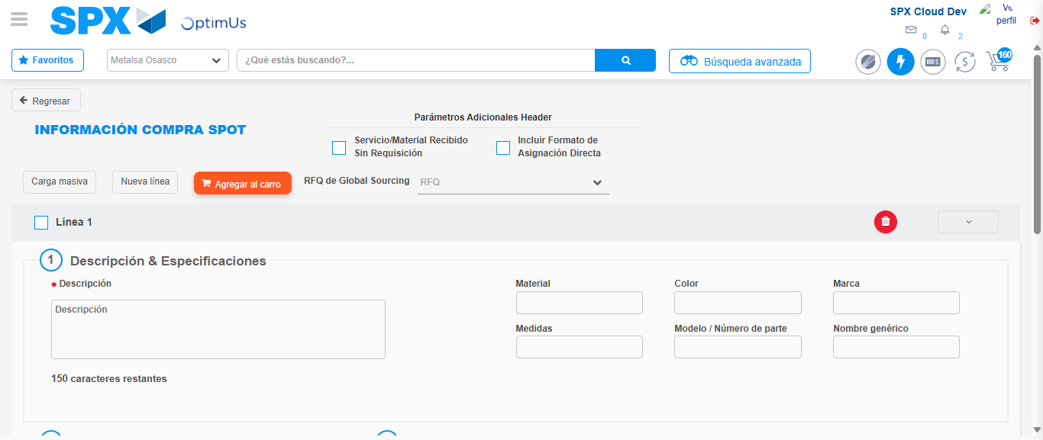Image file-name: QC_Testing-tc003_SPX_Dev5_Crear_Requisicion_Spot_Tipo_Cobro_CC_Urgent-1785344755541

Step 3 - Data Capture Spot Buy Requisition: Data captured correctly
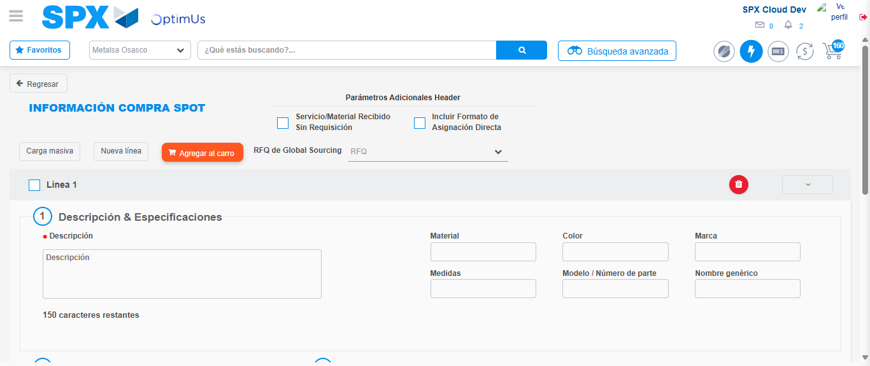Image file-name: QC_Testing-tc003_SPX_Dev5_Crear_Requisicion_Spot_Tipo_Cobro_CC_Urgent-1785344755801

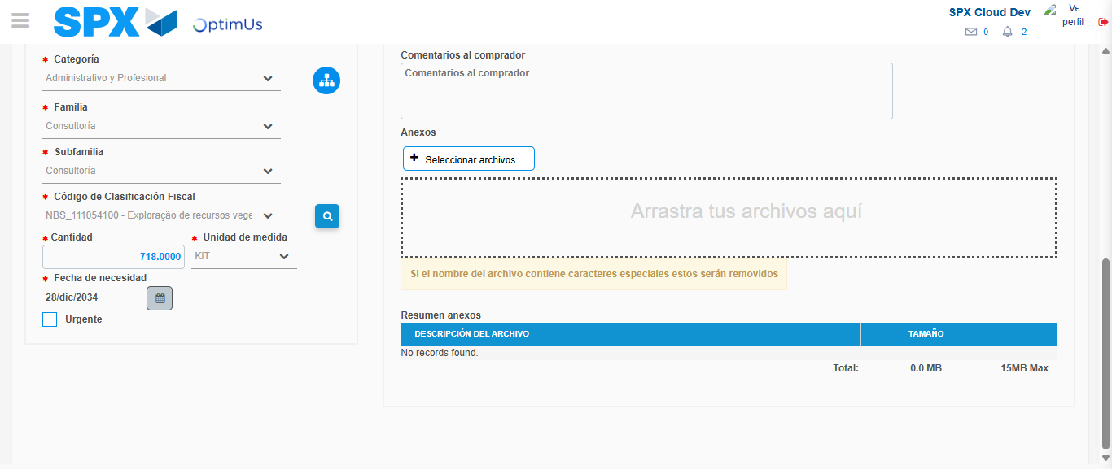Image file-name: QC_Testing-tc003_SPX_Dev5_Crear_Requisicion_Spot_Tipo_Cobro_CC_Urgent-1785344768093

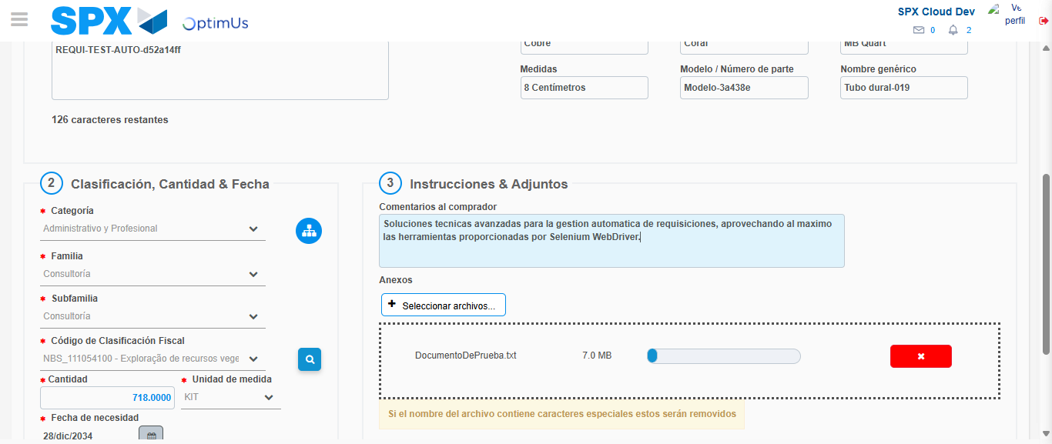Image file-name: QC_Testing-tc003_SPX_Dev5_Crear_Requisicion_Spot_Tipo_Cobro_CC_Urgent-1785344768802

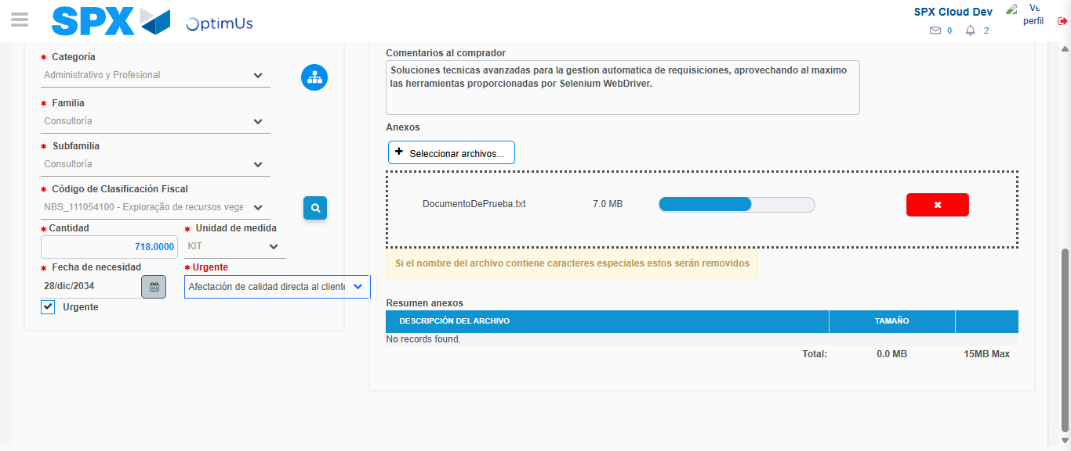Image file-name: QC_Testing-tc003_SPX_Dev5_Crear_Requisicion_Spot_Tipo_Cobro_CC_Urgent-1785344772391

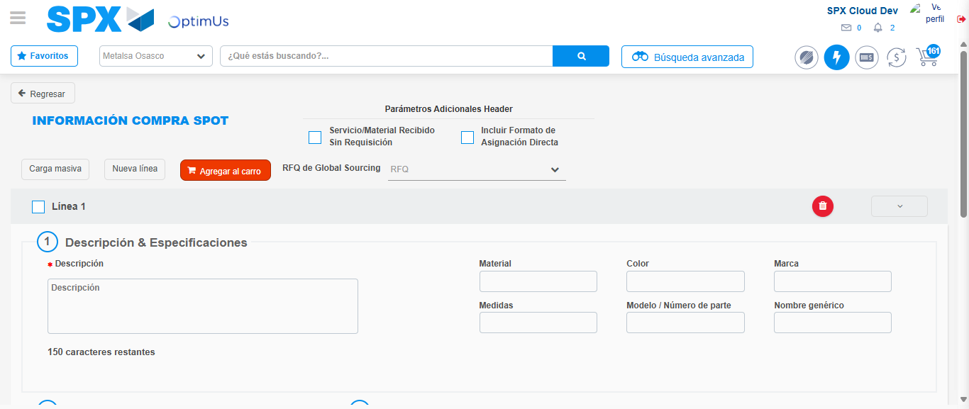Image file-name: QC_Testing-tc003_SPX_Dev5_Crear_Requisicion_Spot_Tipo_Cobro_CC_Urgent-1785344781912

Step 7 - Return to Main Page SPX : Return to Main Page SPX
Image file-name: QC_Testing-tc003_SPX_Dev5_Crear_Requisicion_Spot_Tipo_Cobro_CC_Urgent-1785344727955

Image file-name: QC_Testing-tc003_SPX_Dev5_Crear_Requisicion_Spot_Tipo_Cobro_CC_Urgent-1785344730558

Image file-name: QC_Testing-tc003_SPX_Dev5_Crear_Requisicion_Spot_Tipo_Cobro_CC_Urgent-1785344755541

Image file-name: QC_Testing-tc003_SPX_Dev5_Crear_Requisicion_Spot_Tipo_Cobro_CC_Urgent-1785344784133

Image file-name: QC_Testing-tc003_SPX_Dev5_Crear_Requisicion_Spot_Tipo_Cobro_CC_Urgent-1785344784296

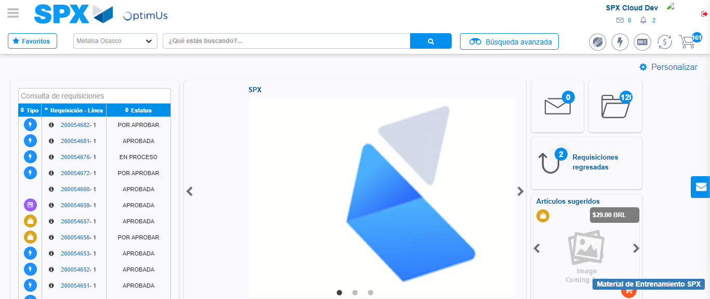Image file-name: QC_Testing-tc003_SPX_Dev5_Crear_Requisicion_Spot_Tipo_Cobro_CC_Urgent-1785344805306

Step 8 - Log Out : Log Out SPX
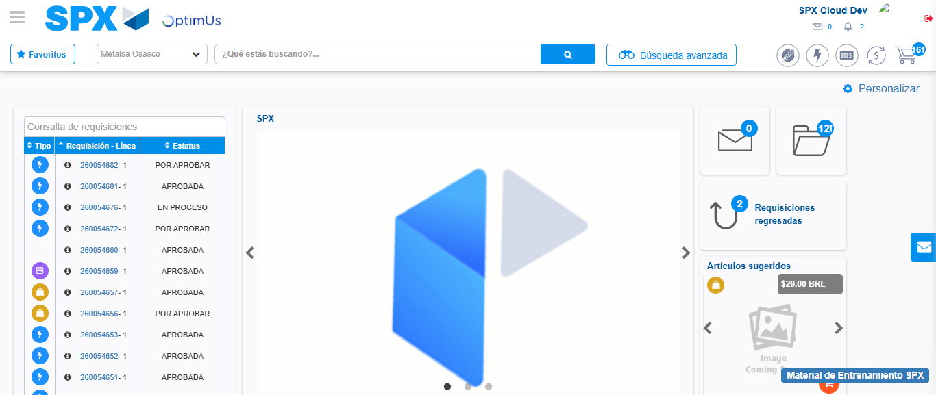Image file-name: QC_Testing-tc003_SPX_Dev5_Crear_Requisicion_Spot_Tipo_Cobro_CC_Urgent-1785344805571

